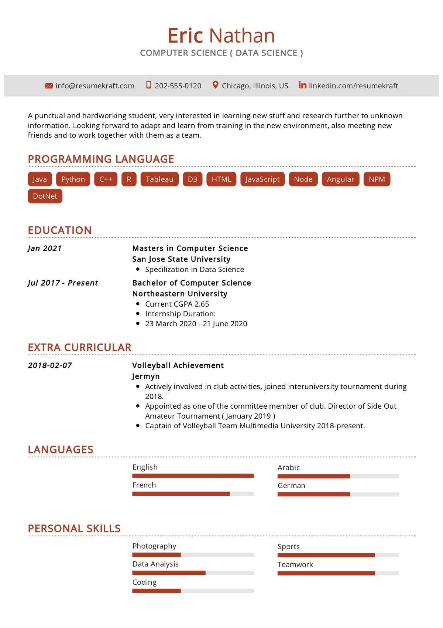
info@resumekraft.com
Eric Nathan
COMPUTER SCIENCE (DATA SCIENCE)
202-555-0120
Chicago, Illinois, US in linkedin.com/resumekraft
A punctual and hardworking student, very interested in learning new stuff and research further to unknown information. Looking forward to adapt and learn from training in the new environment, also meeting new friends and to work together with them as a team.
PROGRAMMING LANGUAGE
Java Python C++ R Tableau D3 HTML
JavaScript Node Angular NPM
DotNet
EDUCATION
Jan 2021
Jul 2017 - Present
Masters in Computer Science San Jose State University • Specilization in Data Science Bachelor of Computer Science Northeastern University
• Current CGPA 2.65
• Internship Duration:
23 March 2020 - 21 June 2020
EXTRA CURRICULAR
2018-02-07
LANGUAGES
Volleyball Achievement Jermyn
• Actively involved in club activities, joined interuniversity tournament during 2018.
• Appointed as one of the committee member of club. Director of Side Out Amateur Tournament (January 2019)
• Captain of Volleyball Team Multimedia University 2018-present.
English
French
Arabic
German
PERSONAL SKILLS
Photography
Data Analysis
Coding
Sports
Teamwork

